1. Print Student Grade based on Marks:

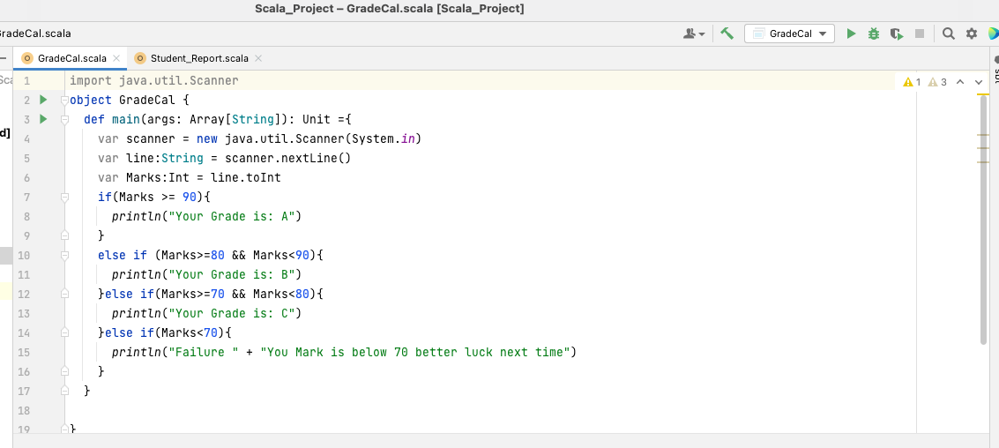

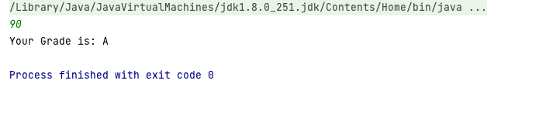

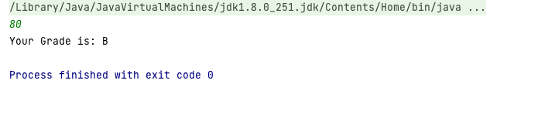

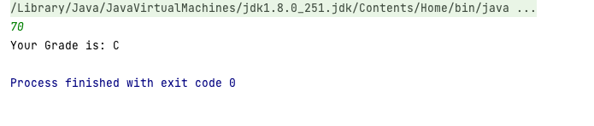

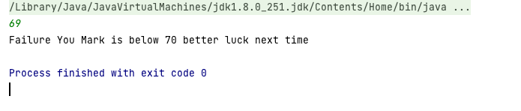

1. WAP to Calculate maximum % Scored report:
2. Sorting Based on ID and Name: